How to pray for Unreached People Groups
- Ask God to show you a people group to pray for, perhaps an ethnic minority group or diaspora group of people in your community or nation. Perhaps a group who you know about through someone in your church who is working near this group. Perhaps where your church have sent or are hoping to send mission workers. Perhaps a group which caught your attention through the news or a talk?
- Research: Find out more about this group of people. You could visit the Joshua Project website , you could use your web browser to find out about the political and socioeconomic situation. What do these people value, enjoy, like to eat? When are there special festivals or celebration days in their culture? What languages do they speak? Operation World also have lots of information to help you.
- Family Times and Routines: Find a time with others in your family, or online, or a small group to pray together for the unreached people group that you have decided to commit to pray for. Eg After a meal time, or children’s bedtime, before work.
- Involve the Children: If you don’t know where to start, then please download and print this booklet to pray for the most unreached people groups in the world. Additionally, 5 times a year there are children’s colouring pages and resources created to help young children pray for people with a particular religious background. Those resources are found here on the 110cities website. Take a look at 2BC resources as well and perhaps join the monthly online prayer time for children called SHINE.
- ADOPT: To really hear and see how your prayers are impacting the world and helping people who are making disciples amongst the people group that you have chosen, the best idea is to make the commitment to “ADOPT” the group of people in prayer. This way you will receive information about what God is doing amongst them and what the current needs are. Please follow the link on the Joshua Project website.
Below are some bible verses and topics which would be helpful to start in your prayer times.
DID YOU KNOW IMPORTANT FACTS:
- Frontier People Groups (FPGs) are a segment of all the unreached peoples groups but have no or very few believers in Jesus. (0.1% or less) and no sustained Jesus movements.
- 90% of the global FPG population lives in India and Muslim Majority Countries.
- 96% of global Christian workers serve reached areas, only 1% in Frontier People Groups FPGs.
- India holds 50% of all FPGs, South Asia 70%. They target the 288 FPGs ( people groups with more than 1 million in population), which is 80% of the world FPG population.
- The largest people groups with populations over 10 million numbers 37 people groups and this covers 50% of all FPGs
- Forty years ago, 50% of humanity lived in people groups with almost no believers. Today, only 25% of humanity lives in people groups with no internal witness.
- 40% of humanity lives in Unreached People Groups (UPGs). Just 4% of harvest labourers work among this 40%, mostly with existing churches. Non-believers here are a significant cultural distance from most believers

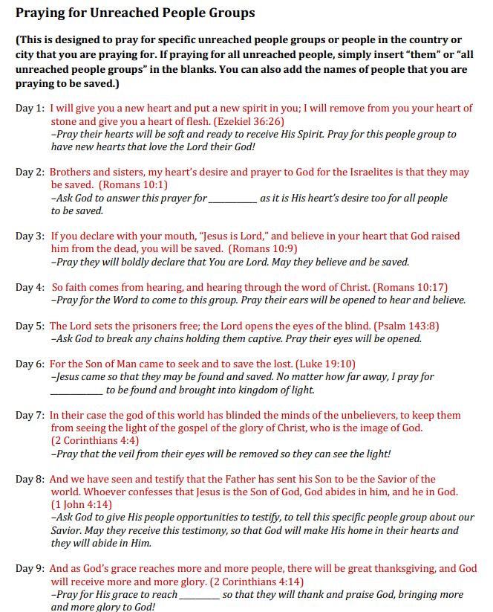
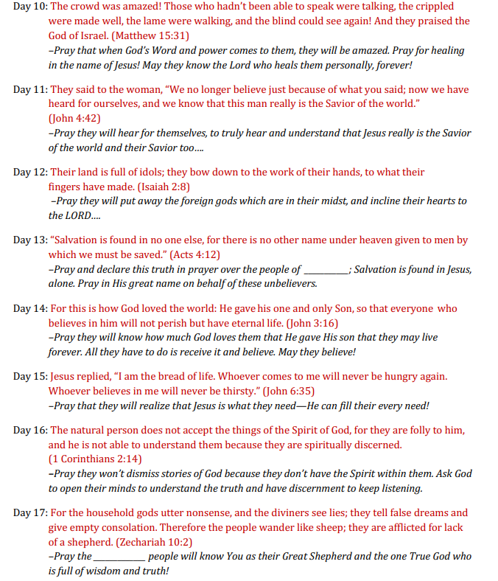

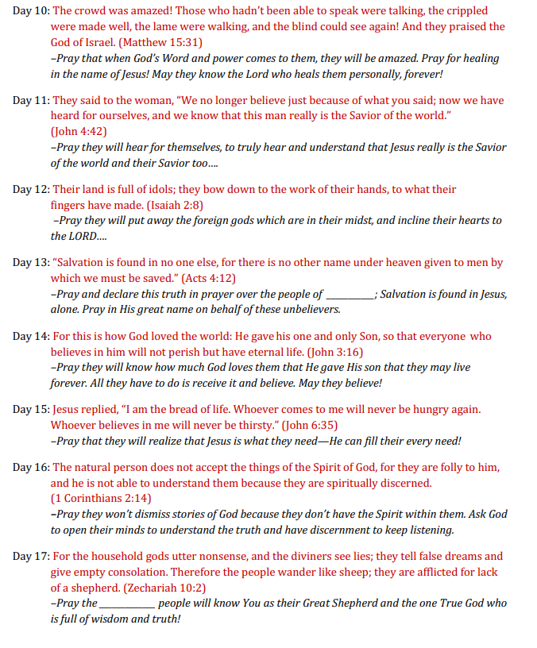

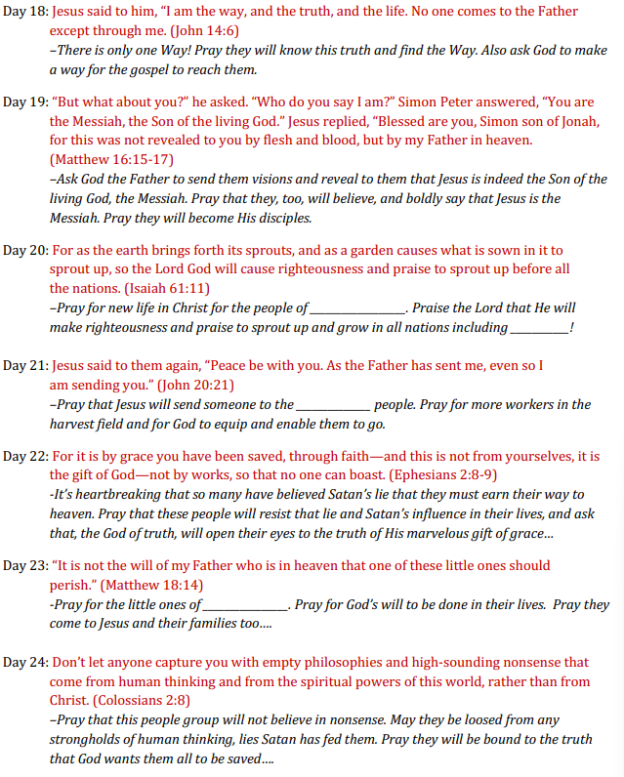

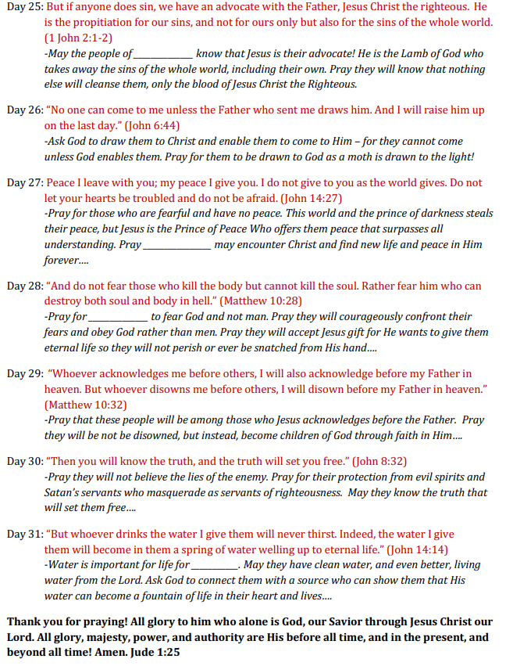

Pray for all Unreached People Groups (UPGs) and Frontier People Groups (FPGs) globally:
1.Pray for God to pour out His Holy Spirit for every Unreached People Group to have a movement to Christ by 2027. Pray that He will raise up many prayer teams to advocate for each of these 31 largest FPGs, praying until the blessing of knowing Jesus is spreading rapidly from family to family (Ps 2:8, James 4:2b).
2.Pray that God will cause the revelation of His love and His Word to run swiftly across the earth until He is honored and worshiped by all peoples, including Oral and Bible-less Peoples. Pray that He will exalt His Word among every UPG through Bible Translation and Orality movements by 2025 (2 Th 3:1; Eph 4:16).

For Teams Advocating for Specific Larger FPGs:
- Pray for God to bring forth His blessing—strengthening and healing families and communities within your chosen people group. Ask God to cause His abundant life and love through Jesus to be widely embraced by the families and clans of your group (Gen 12:5, 28:14; Acts 3:25, 10:43).
- Pray that God will overthrow the spiritual forces of darkness that oppose the spread of His Gospel, and send His people to bless and overcome suffering and evil in His name. Ask God to deliver the families and communities in your chosen FPG from false perceptions of the gospel as a threat to their identity. Ask the Holy Spirit to replace any fear in your FPG with love, power, and self-discipline, as God’s blessing flows from family to family (Rom 12:21, Gen 3:10, Is 25:7, II Tim 1:7).
- Pray for God to pour out His blessing on the religious and secular leaders of your chosen Frontier People Group. Ask Him to bless the families of these leaders, and inspire whole communities to welcome salvation through faith in Jesus (I Tim 2:1-5).
- Pray for the Holy Spirit to lead the people of your chosen Frontier People Group to love His Word and spread its influence, so that your chosen people group will love Him with their whole being and walk in His ways (Acts 6:7, 12:24, 19:20; Mk 12:29-31).
- Pray for God to pour out His Holy Spirit in anointing the families of your chosen Frontier People Group, especially the children and youth. Beg (deomai) God to raise up and send out (ekballo) a new generation of fruitful, multiplying witnesses within your chosen people group (Mt 9:37–38, Lk 10:2).

VERSES TO PRAY OVER THE NATIONS (Put the country/nationality you are praying for in the gaps)
Ps 22: 27 All the ends of the ______will remember and turn to the LORD, and all the families of ________ will bow down before him, 28 for dominion belongs to the LORD and he rules over ______.
Ps 57:5 Be exalted, O God, above the heavens; let your glory be over _______.9 I will praise you, O Lord, among ______; I will sing of you among the ________.10 For great is your love, reaching to the heavens; your faithfulness reaches to the skies.11 Be exalted, O God, above the heavens; let your glory be over all of _____.
Ps 67: 1 May God be gracious to _____and bless ______ and make his face shine upon _____,Selah
2 that your ways may be known in _______, your salvation among all ________.3 May the peoples praise you, O God; may all the ______ praise you.4 May _______be glad and sing for joy, for you rule the peoples justly and guide the nations of the earth. Selah
5 May all _______ praise you, O God; may all _____ peoples praise you.6 Then ______ will yield its harvest, and God, our God, will bless ________.7 God will bless ______, and all the ends of the earth will fear him.
Ps 66:1-4. Shout with joy to God, all of _______ Sing the glory of his name _______; make his praise glorious. Say to God, ‘How awesome are your deeds! So great is your power ….. All _____ bows down to you; _______ sing praises to you, they sing praises to your name.’
Isa 9:2 The people living in ______ have seen a great light; on those living in the land of _____ (in) the shadow of death a light has dawned

Isa 11:9. ‘For _____ will be full of the knowledge of the Lord as the waters cover the sea.’
Isa 49:8 8 This is what the LORD says: "In the time of my favor I will answer you ______, and in the day of salvation I will help you ____; I will keep you ______and will make you to be a covenant for the people, to restore the land and to reassign its desolate inheritances,9 to say to the captives, 'Come out,' and to those in darkness, 'Be free!' "______ will feed beside the roads and find pasture on every barren hill. 10 ______ will neither hunger nor thirst, nor will the desert heat or the sun beat upon them. He who has compassion on them will guide _____ and lead them beside springs of water.
Isa 51:3-5 The Lord will surely comfort ____ and will look with compassion on all her ruins; he will make ______ deserts like Eden, ______ wastelands like the garden of the Lord. Joy and gladness will be found in ____ thanksgiving and the sound of singing. …. The law will go out from me; my justice will become a light to _____ . My righteousness draws near speedily (to) ______, my salvation is on the way (to) ______
Zec 2:10-11 ‘ Shout and be glad, O ____ For I am coming, and I will live among you _______,’ declares the Lord. ______ will be joined with the Lord in that day and ______ will become my people. I will live among you and (all) _______ will know .. the Lord Almighty.’
Acts 28:28 ‘Gods salvation has been sent to ____ and they will listen!’
Rom 1:16 ‘The gospel … is the power of God for the salvation of every ___ who believes.’
Phil 2:10-11 ‘At the name of Jesus every ______ knee should bow in heaven and on earth and under the earth, and every _______ tongue confess that Jesus Christ is Lord, to the glory of God the Father.

